ENGINEERING SPECIFICATION

FIBERGRATE® MOLDED HIGH LOAD CAPACITY (HLC) GRATING

SECTION 06610

FIBERGLASS REINFORCED PLASTICS (FRP) FABRICATIONS

MOLDED HIGH LOAD CAPACITY (HLC) GRATING

PART 1 - GENERAL

1.01 RELATED DOCUMENTS

- Drawings and general provisions of Contract, including General and Supplementary Conditions and Division 1 Specification Sections, apply to this section.

B. DRAFT of The Fiberglass Grating Manual, ANSI/ASCE/ACMA

C. The publications listed below (latest revision applicable) form a part of this specification to the extent referenced herein. The publications are referred to within the text by the designation only.

AMERICAN SOCIETY FOR TESTING AND MATERIALS (ASTM) Test Methods:

ASTM D 635 Rate of Burning and/or Extent and Time of Burning of Self-Supporting Plastics in a Horizontal Position

ASTM E 84 Surface Burning Characteristics of Building Materials

  - SUMMARY

A. This section includes shop fabricated fiberglass reinforced plastic (FRP) Molded High Load Capacity (HLC) Grating.

1.03 SCOPE OF WORK

A. Furnish, fabricate (where necessary), and install all fiberglass reinforced plastic (FRP) HLC gratings with all appurtenances, accessories and incidentals necessary to produce a complete, operable and serviceable installation as specified herein.
.
1.04 SUBMITTALS

- Submit manufacturer's shop drawings of all fabricated gratings clearly showing material sizes, types, styles, part or catalog numbers, complete details for the fabrication of and erection of components including, but not limited to, location, lengths, type and sizes of fasteners and connection details.

- Submit the manufacturer’s published literature including structural design data,
structural properties data, grating load/deflection tables, corrosion resistance tables, certificates of compliance, test reports as applicable and design calculations for systems not sized or designed in the contract documents.

C. Submit sample pieces of each item specified herein, manufactured by the method used in the Work and as to quality and color.

1.05 QUALITY ASSURANCE

- All items to be provided under this Section shall be furnished only by manufacturers having experience in the design and manufacture of similar products and systems. If requested, experience shall be demonstrated by a record of at least five (5) previous, separate, similar successful installations in the last five (5) years.

- Manufacturer shall offer a 3 year limited warranty on all FRP products against defects in materials and workmanship.

- Manufacturer shall be certified to the ISO 9001-2000 standard.

- Manufacturer shall provide proof of certification from at least two other quality assurance programs for its facilities or products (UL, DNV, ABS, USCG, AARR).

  - DESIGN CRITERIA

- The design criteria of the FRP products including connections shall be in accordance with governing building codes and generally accepted standards in the FRP industry.

- Allowable Spans for Vehicular Loads shall not exceed those shown in the following table:

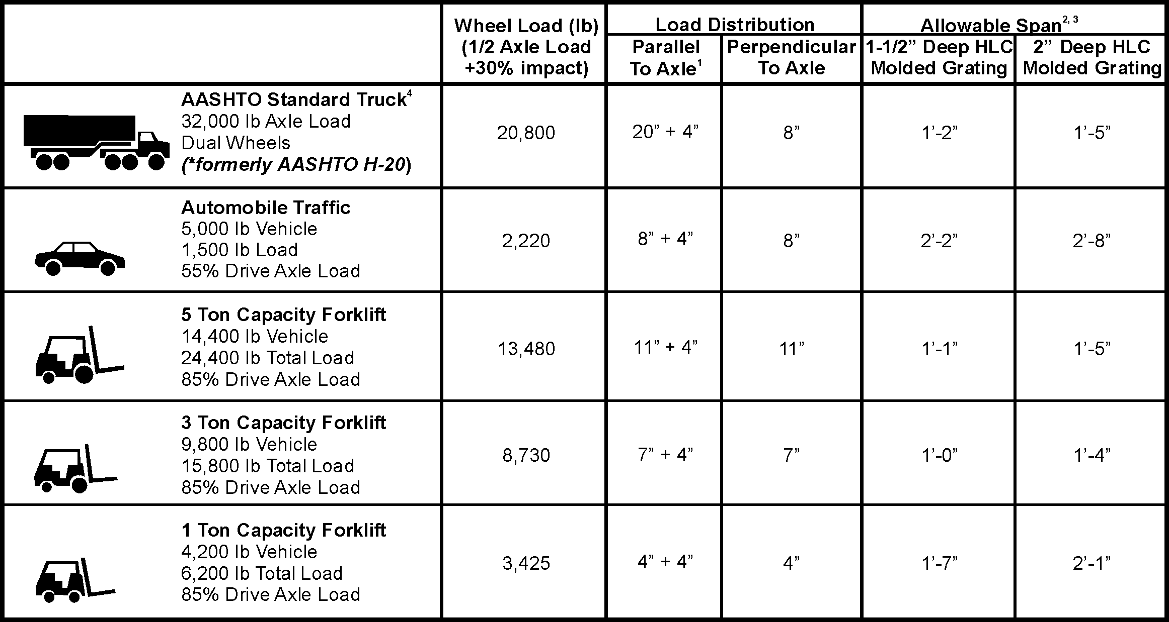
Notes:
- Load is carried by the grating load bars immediate under wheel + four additional load bars adjacent to wheel.
- Allowable Span is based on a 0.25” maximum deflection and a Factor of Safety of 3.0. The other criteria may be required by certain construction codes. Check code requirements to determine design criteria.
- ALLOWABLE SPAN IS STRONGLY DEPENDENT ON WHEEL WIDTH AND VEHICLE WEIGHT/LOAD CAPACITY. If your application varies from the values given on this table, contact Fibergrate Engineering for application assistance.
- Load based on the AASHTO Standard Truck Load as defined in AASHATO LRFD Bridge Design Specifications, 2nd Ed. This does not imply that the allowable span meets the deflection requirements of this specification.

1.07 PRODUCT DELIVERY AND STORAGE

A. All gratings and components shall be shop fabricated and piece match marked to assembly or erection drawings.

B. Delivery of Materials: All manufactured materials shall be delivered in original, unbroken pallets, packages, containers, or bundles bearing the label of the manufacturer. Adhesives, resins and their catalysts and hardeners shall be crated or boxed separately and noted as such to facilitate their movement to a dry indoor storage facility.

C. Storage of Products: All materials – before, during and after shipment - shall be carefully handled to prevent them from abrasion, cracking, chipping, twisting, other deformations, and other types of damage. Store items in an enclosed area and free from contact with soil and water. Store adhesives, resins and their catalysts and hardeners in dry indoor storage facilities between 70 and 85 degrees Fahrenheit (21 to 29 degrees Celsius) until they are required.

PART 2 - PRODUCTS

2.01 GENERAL

A. All FRP items furnished under this Section shall be composed of fiberglass reinforcement and resin in qualities, quantities, properties, arrangements and dimensions as necessary to meet the design requirements and dimensions as specified in the Contract Documents.

B. Fiberglass reinforcement shall be continuous roving in sufficient quantities as needed by the application and/or physical properties required.

C. Resin shall be Corvex® or Vi-Corr® with chemical formulations as necessary to provide the corrosion resistance, strength and other physical properties as required.

D. All finished surfaces of FRP items and fabrications shall be smooth, resin-rich, free of voids and without dry spots, cracks, crazes or unreinforced areas. All glass fibers shall be well covered with resin to protect against their exposure due to wear or weathering.

E. All grating products shall have a Class 1 Fire Rating and a tested flame spread rating of 25 or less per ASTM E-84 Tunnel Test. Gratings shall also meet the self-extinguishing requirements of ASTM D635.

- All mechanical grating clips shall be manufactured of Type 316SS (stainless steel).

G. Molded High Load Gratings shall be Fibergrate® as manufactured by:

Fibergrate Composite Structures Inc.
5151 Belt Line Road, Suite 700
Dallas, Texas 75254-7028 USA
(800) 527-4043 (972) 250-1530 Fax

and distributed in Canada by:

Fibergrate Canada
95 Sunray Street
Whitby, Ontario, L1N 9C9
(800) 263-3112 (905) 430-3056 Fax

2.02 MOLDED HIGH LOAD CAPACITY (HLC) FRP GRATING

A. Manufacture: Grating shall be of a one-piece molded construction with tops and bottoms of bearing bars and cross bars in the same plane. Grating shall have a rectangular mesh pattern and have substantial bi-directional strength. Grating shall be reinforced with continuous rovings of equal number of layers in each direction. The top layer of reinforcement shall be no more than 1/8" (3.18mm) below the top surface of the grating so as to provide maximum stiffness and prevent resin chipping of unreinforced surfaces. Percentage of glass (by weight) shall not exceed 45% so as to achieve maximum corrosion resistance, and as required to maintain the structural requirements of the CONTRACT.

After molding, no dry glass fibers shall be visible on any surface of bearing bars or cross bars. All bars shall be smooth and uniform with no evidence of fiber orientation irregularities, interlaminar voids, porosity, resin rich or resin starved areas.

Color: Dark Gray

- Depth: 1-1/2” or 2” (38.1mm or 50.1mm) with a tolerance of plus or minus 1/16" (1.6mm).

- Mesh Configuration: 1” X 2” (25.4 x 50.8mm) with a tolerance of plus or minus 1/16" (1.6mm) mesh centerline to centerline.

- Grating bar intersections are to be filleted to a minimum radius of 1/16” to eliminate local stress concentrations and the possibility of resin cracking at these locations.

- Panel Size: 4’-0” X 8’-0” (1220 x 2440mm) with load bars perpendicular to the 4’- 0” (1220 mm) direction.

- Substitutions: Other products of equal strength, stiffness, corrosion resistance and overall quality may be submitted with the proper supporting data to the engineer for approval.

2.03 GRATING FABRICATION

A. Measurements: Grating supplied shall meet the dimensional requirements and tolerances as shown or specified. The Contractor shall provide and/or verify measurements in field for work fabricated to fit field conditions as required by grating manufacturer to complete the work.

B. Layout: Each grating section shall be readily removable, except where indicated on drawings. Gratings shall be fabricated free from warps, twists, or other defects which affect appearance and serviceability.

C. Sealing: All shop fabricated grating cuts shall be coated with vinyl ester resin or equivalent recommended by manufacturer to provide maximum corrosion resistance. All field fabricated grating cuts shall be coated similarly by the contractor in accordance with the manufacturer's instructions.

D. Hardware: If required by the contract drawings, Type 316 stainless steel hold-down clips shall be provided and spaced as per the recommendation of the manufacturer.

PART 3 - EXECUTION

3.01 INSPECTION

- Shop inspection is authorized as required by the Owner and shall be at Owner's expense. The fabricator shall give ample notice to Contractor prior to the beginning of any fabrication work so that inspection may be provided. The grating shall be as free, as commercially possible, from visual defects such as foreign inclusions, delamination, blisters, resin burns, air bubbles and pits. The surface shall have a smooth finish (except for grit top surfaces).

3.02 INSTALLATION

- Contractor shall install gratings in accordance with manufacturer’s assembly drawings. Lock grating panels securely in place with hold-down fasteners as specified herein. Field cut and drill fiberglass reinforced plastic products with carbide or diamond tipped bits and blades. Seal cut or drilled surfaces in accordance with manufacturer's instructions. Follow manufacturer's instructions when cutting or drilling fiberglass products or using resin products; provide adequate ventilation.

